1 ANALYSIS OF OXYGEN TRANSPORT TO TUMOR TISSUE BY MICROVASCULAR NETWORKS

The median diameter of microvessels ranged from 23 pm to 85 pm in tumor tissues, with a mean of 53 pm, compared to 20 pm in normal tissues. The increased vessel diameters observed in tumor

preparations implies that relatively large diameter vessels are responsible for oxygen exchange in these tissues. The median spacing between microvessels was 28 1 pm in tumor tissues, compared to 158 pm in normal tissues.

This paper showed that some feature of the numerical result, including normal analysis, (important)

Relation of inlet flux and hypoxia, relation of oxygen consumption and hypoxia

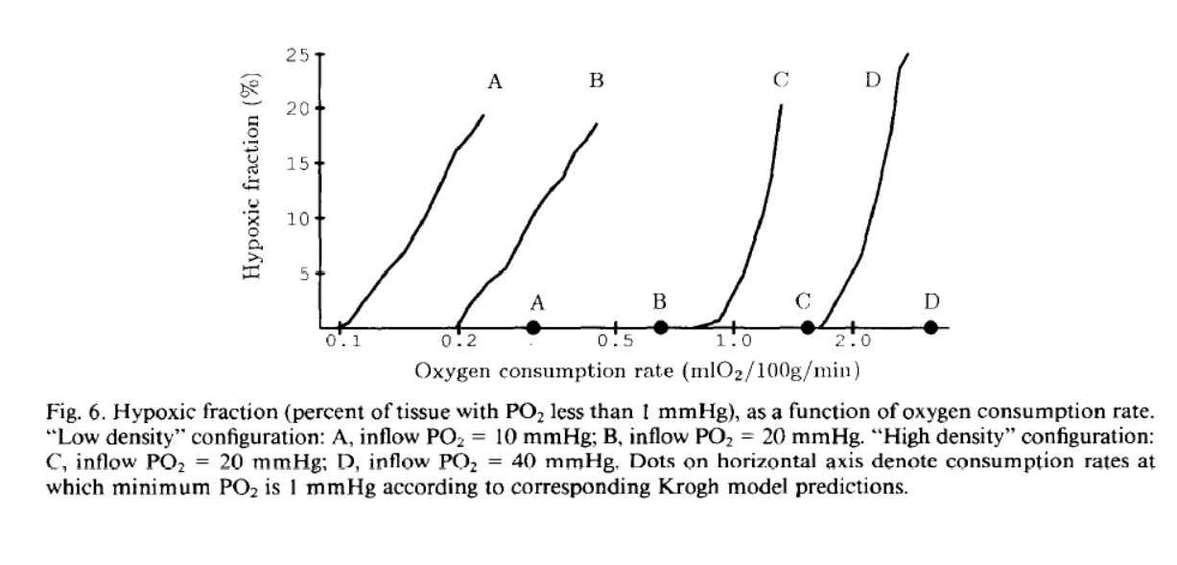2 A Computational Study of the Effect of Capillary Network Anastomoses and Tortuosity on Oxygen Transport.

This paper shows the 3d theoritical result. the numerical result emphasis the diversity of oxygen field, the blood flow and hypoxia region, to against the krogh classical model.

Also the paper shows the The Fahraeus-Lindqvist effect and plasma skimming effect. (viscosity varies when radius change and at bifurcation red cell nontrival behavior)

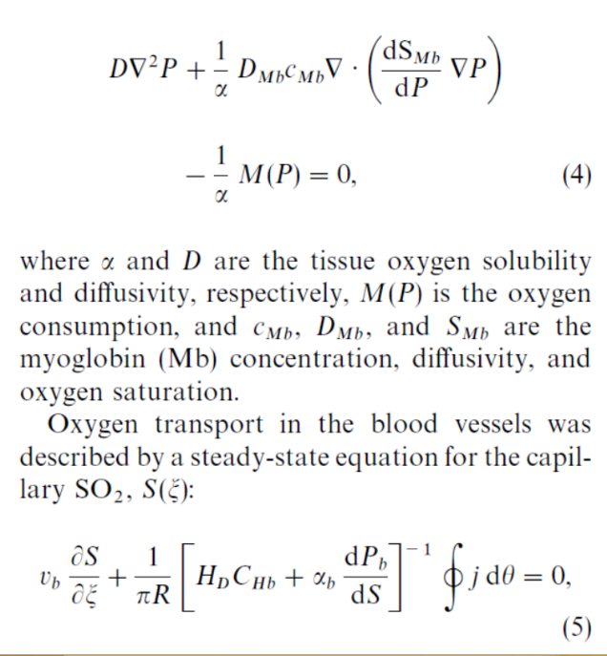

3. A Computational Study of the Effect of Vasomotion on Oxygen Transport from Capillary Networks

Meaningless, covered by 2, the vessel vasomotion changed. In a word, the paper show the blood flow varies lead to the tissue oxygen varies.

4.Vascular network remodeling via vessel cooption, regression and growth in tumors

I haven’t read this paper carefully. The paper roughly give a network and vegf generate and do some simulation. The process is the evolution of a normal blood vessel network with a tumor cell at middle. The paper focus on the tumor size and geometry.

5 Oxygen Transport in Resting and Contracting Hamster Cremaster Muscles: Experimental and

Theoretical microvascular studies

The vessel geometry still parallel. Author use theoretical method give some expansion result. The point is the paper use experiment data, however, the data is very rough. It only gives some average data, like mean po2 in tissue, blood red cell mean density.

6 Theory of oxygen transport to tissue.

book with detail of model developed from krogh.

7Cycling hypoxia and free radicals regulate angiogenesis and radiotherapy response

The paper show that in tomor growth: hypoxia lead to angiogenesis with some factors include vegf hlf etc.

8 THEORY OF OXYGEN TRANSPORT TO TISSUE popel

Popel write the theory of oxygen transport, include many details.

9 origin krogh

10 A Novel Three-Dimensional Computer-Assisted Method for a Quantitative Study of Microvascular Networks of the Human Cerebral Cortex.

The cortex vessel, emphasis the geometry.

11. Study of tissue oxygen supply rate in a macroscopic photodynamic therapy singlet oxygen model

Use krogh model with theoretic expansion for symmetry geometry.

12. A dynamic model of oxygen transport from capillaries to tissue with moving

red blood cells

the paper self consider the very detail of oxygen in blood vessel, such as the red cell in blood vessel.

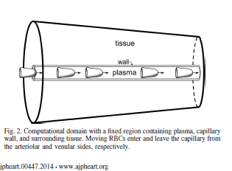

Mension experiment 2 photo experiment is important

13 Blood Velocity ond Volumetric Flow Rote

Older experiment for retinal diameter and velocity relation. Same velocity ,venous bigger than artery

14 The relative influence of hematocrit and red blood cell velocity on oxygen transport from capillaries to tissue

the paper self also consider the very detail of oxygen in blood vessel, such as the red cell velocity as above (Which I think unnecessary for tissue po2)

Using theoretical modeling, hematocrit is shown to have a larger influence on tissue oxygenation around capillaries than RBC velocity, with strongest importance near the arterioles and at high oxygen consumption rates. This challenges the common view that, among blood flow variables, solely the oxygen flux into the capillaries determines the tissue PO2.

Weired??????why?????

15 A mathematical model for the distribution of hemodynamic

Use Bifurcation power to construct a structure tree to express blood vessel for retina. Very similar to CAO HE WEI ‘S work. The experiment can check and l=7\*d^1.15;

16 Blood flow mechanics and oxygen transport and delivery in the retinal microcirculation: multiscale mathematical modeling and numerical simulation

Show a detailed retina structure(6 layers) important!!!. The numerical method takes average po2 for each layer ,no help…

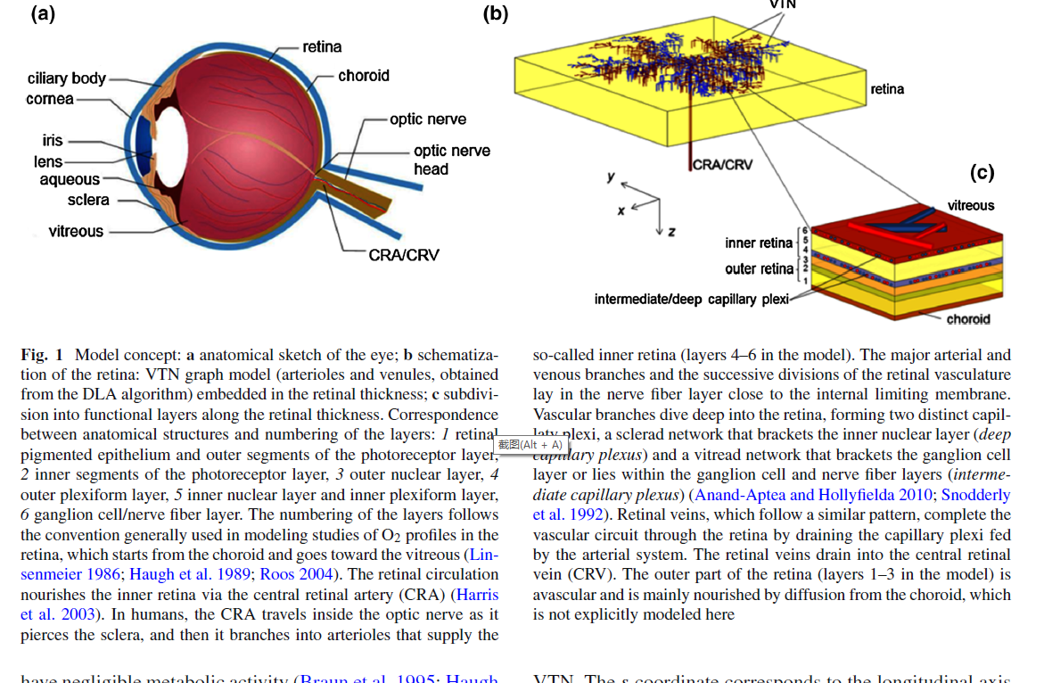

17 Estimating oxygen distribution from vasculature in three-dimensional tumour tissue

Very near to our result, however still bound to krogh model with one capillary supply surround tissue. Use this asymptotic assumption ,use kernal method(very similar to green method), compute a large system. 2016

18 Computational Analysis of Oxygen Transport in the Retinal Arterial Network

Another assumption for simplify the problem, which mean the vessel wall po2 is 40mmhg, meaned experiment, need to check. In my understand, mean the average retinal po2 is 40 mmhg, and also inlet po2 is 100 mmhg at inlet with experiment to support.

19 Physiology of oxygen transport

Some Physiology result for oxygen and work and breath

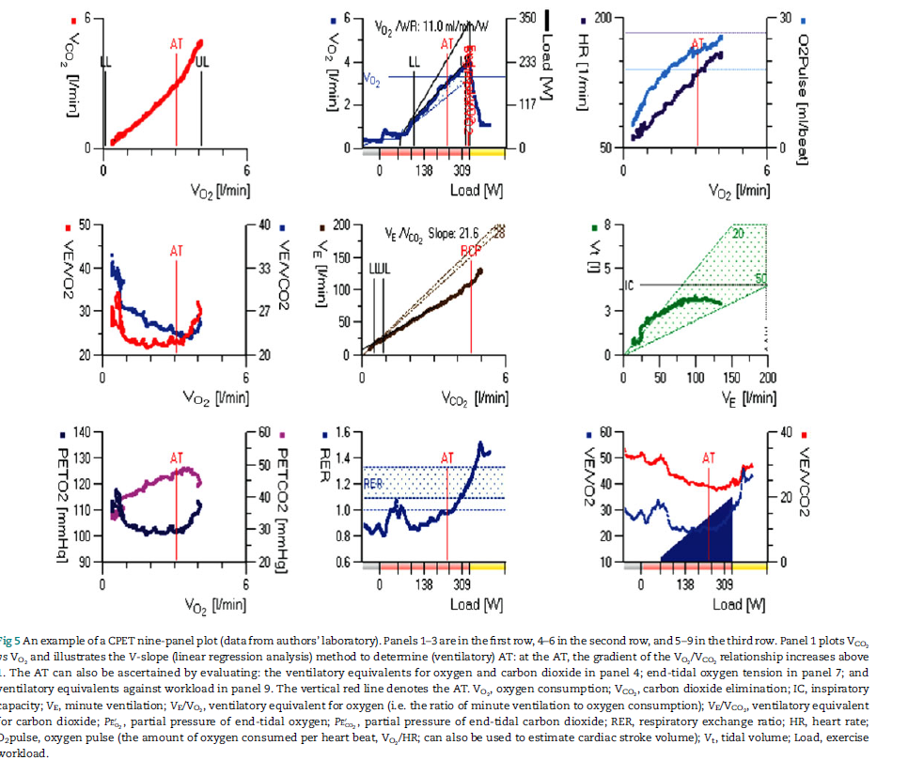

20 Green’s Function Methods for Analysis of Oxygen Delivery to Tissue by Microvascular Networks

Secomb green function

21Oxygen distribution and consumption in the macaque retina

Experiment for 40mmhg

22Automatic Retinal Oximetry

Experiment for inlet 100 mmhg

23Theoretical Models of Microvascular OxygenTransport to Tissue

Goldman theory, a complete version for popel

24Simultaneous two-photon imaging of oxygen and blood flow in deep cerebral vessels

Precise experiment two-photon imaging of oxygen